**20. Draw generalization hierarchy of your classes and all their details like shown in chapter 5 page 30-31 .**

System

Users

Admin

People

Students

Others (teacher,engineer)

Users

E-mail

password

name

Admin

Controlling systems

Evaluation

People

Question answering

View results

**21. Draw aggregation associations of all your classes like shown in chapter 5 page 33.**

User Record

Language

User

Question

**22. Draw activity model of your application like shown in chapter 5 page 36**

e-mail

password

LogIn

Register

evaluation

LogOut

View languages

Choosing a language

View Result

Options Based Question

Completing Questions

Question Answering

**23. Draw your application processes like shown in chapter 5 page 37.**

[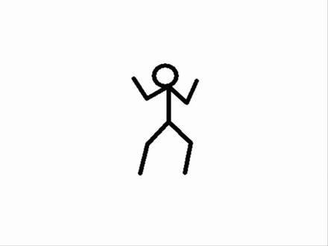](https://www.google.com/url?sa=i&rct=j&q=&esrc=s&source=images&cd=&cad=rja&uact=8&ved=2ahUKEwiQoKSinqrfAhUE_KQKHRNrC8wQjRx6BAgBEAU&url=https://www.vidivodo.com/cin-ali-2&psig=AOvVaw0st4xKTerZQKTJ9D17aava&ust=1545251935451678)

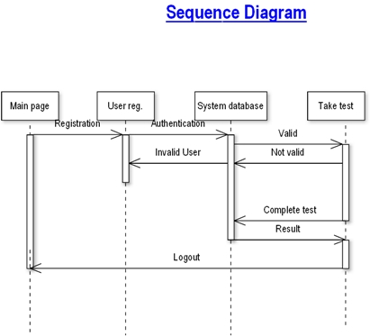

**24. Draw state diagram of your application like shown in chapter 5 page 40.**

User Validation Not Valid User Valid User

Taking exam

Checking for Valid user

User registration

**25. Prepare structured forms of your application’s states like shown in chapter 5 page 41-42.**

|  |  |
| --- | --- |
| **Stimulus:** | **Description:** |
| SignIn | The user has signed in. |
| SignOut | The user has signed out. |
| Home | The user has seen types of languages. |
| History | The user has seen languages. Languages are answered by self. |
| Ranking | The user has seen scores of other people and self. |
| About Us | The user has seen Toros University website. |
| Admin | Admin has signed in and has controlled system. |

|  |  |
| --- | --- |
| Developer | The user has seen developers. |
| Feedback | The user has sent wishes and problems. |
| Start | The user has started exam. |
| Restart | The user has started exam again. |
| Add Quizz | Admin has added new quizz. |
| Remove Quizz | Admin has updated quizz. |
| User | Admin has seen users who they anwered questions. |
| Feed | Admin has done feed back to user. |

**26. Draw the software architecture of your project like shown in chapter 6 page 42, 49.**

**INPUT PROCESS OUTPUT**

View Answers

View Questions

Update Account

E-mail

Password

**User Database User**

User Registration

Start Exam

End Exam

View Result

Taking Test

Search for User

Update User

View User Details

Register User

**27. Draw context diagram of your project like shown in chapter 7 page 9.**

Controlling System

**1 1 1 1…n 1 1…n**

Information of User

Taking Exam

**28. Draw high level architecture of your project like shown in chapter 7 page 13.**

Subsystem

Management of Feedback

Subsystem

Management of Ranking

Online Exam System

Subsystem

Management of Users

Subsystem

Management of Database

Subsystem

Management of Quizz

**29. Draw all object classes of your project like shown in chapter 7 page 19.**

Test Details

id:int

Test Result:int

Take test()

End test ()

User Registration

id:int

name:varchar(50)

DOB:datetime

Gender:varchar(10)

Branch:varchar(20)

College:varchar(50)

uid:varchar

pwd:varchar(20)

rpwd(20)

que:varchar(500)

ans:varchar(500)

Update User()

View User Result()